***Application for the***

**EuroSpeleo Protection Label FSE 2025**

Ref: FSE/ECPC/ESPL_Application-Form-2025_v1

Name and acronym of the project:

………………………………………………………………………………………………………..

Beneficiary organisation (Name, Country, Full Address, Contact): …………………………………………………………………………………………………………

…………………………………………………………………………………………………………

Person in charge of the project (Name, e-mail, telephone):

…………………………………………………………………………………………………………

Person in charge of the follow-up on the ESPL application (Name, e-mail, telephone)

…………………………………………………………………………………………………………

Bank details:

IBAN………………………………….......................... BIC……………………………….........

Bank Name:

Bank Address:

Account Holder name:

Organisation representing your country in the FSE and responsible for providing the supporting letter

for your application to the ESPL:

…………………………………………………………………………………………………………

Place of project implementation:

…………………………………………………………………………………………………………

Key dates of the project (i.e. maximum 3 activities important for project’s progress and outreach):

…………………………………………………………………………………………………………

…………………………………………………………………………………………………………

…………………………………………………………………………………………………………

Expected results and long-term integrated ecological sustainability of your project?

…………………………………………………………………………………………………………

…………………………………………………………………………………………………………

…………………………………………………………………………………………………………

***Form to be sent by e-mail before the 30th of April 2025 to:***[protection@eurospeleo.eu](mailto:protection@eurospeleo.org)

**A project proposal includes the following components:**

1. A fully completed and accurate Application Form.

2. Project summary (abstract) in a separate file (250 words).

3. Presentation of the protection relevant needs in alignment with the European Speleological Charta for

Cave Protection (FSE) including steps for implementation (300 words);

4. Description of the expected project results and long-term integrated ecological sustainability while

emphasising the used approaches that will advance the current state of the field (350 words);

5. Explanation of the involvement of cavers, co-organisations, partners and stakeholders (100 words);

6. Overview of media and public outreach strategies (50 words);

7. A project Budget (in EUR), with a breakdown of the main budget categories (i.e. income, travel, equipment,

consumables, and other expenses);

8. Inclusion of a letter from the national speleological organization, which is a member of the FSE, certifying its

support for the project.

All the points listed are mandator, and failure to provide the requested information will lead to the rejection of the project proposal.

For more detailed guidance, you can refer to the ESPL Application-Guidelines 2025.

([https://www.eurospeleo.eu/ECPC/espl/)](https://www.eurospeleo.eu/ECPC/espl/)

Note: All documents must to be provided in either pdf or doc format.

**EuroSpeleo Protection Label is supported by the FSE Partners:**

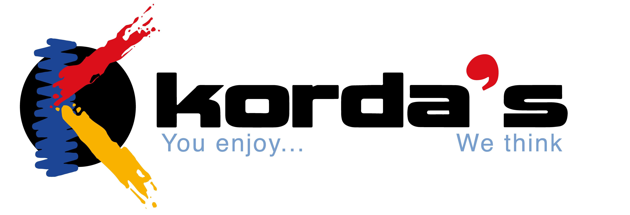

Aventure Verticale Equipment Korda’s Ropes Scurion Lamps